**ULTRASONIC MOSQUITO REPELLENT**

5/19/2025

BAHRIA UNIVERSITY E-8 CAMPUS

Applied Physics Lab

SEMESTER PROJECT REPORT

**GROUP MEMBERS**

**Abdul Moiz (01-134251-004)**

**Zain Abbas (01-134251-101)**

**Hammad Nadeem (01-134251-023)**

**INSTRUCTOR**

**SIR SIKANDAR HAYAT**

**INSTITUTE**

**BAHRIA UNIVERSITY ISLAMABAD**

**\*\*\*\*\*\*\*\*\*\*\*\*\*\*\*\*\*\*\*\*\*\*\*\*\*\*\*\*\*\*\*\*\*\*\*\*\*\*\*\*\*\*\*\*\*\*\*\*\*\*\*\*\*\*\*\*\*\*\*\*\*\*\*\*\*\*\*\*\*\*\*\*\***

**INTRODUCTION:**

Mosquitoes are common carriers of diseases like malaria and dengue. Traditionally, people rely on chemical repellents like sprays, coils, and creams to keep mosquitoes away, and most chemical repellents used against them can have harmful side effects on humans. As part of our project, we aimed to develop a safer alternative: ultrasonic mosquito repellent.

The device works by generating high-frequency sound waves (around 40 kHz) using a 555 timer IC, which are meant to irritate or repel mosquitoes without affecting humans. This project allowed us to apply basic electronics and physics concepts to build a functional, eco-friendly solution to a real-world problem.

**Objectives of our project:**

* To design and build an ultrasonic mosquito repellent using a 555 timer IC.
* To generate sound waves at a frequency of approximately 40 kHz that repel mosquitoes.
* To create a **chemical-free** and **eco-friendly** alternative to traditional mosquito repellents.
* To apply theoretical knowledge of electronics and frequency generation in a practical project.
* To develop a **low-cost, portable,** and **easy-to-use** solution for mosquito control.

**MATERIALS USED:**

* Breadboard
* NE555 timer IC
* 1kΩ resistor (R1)
* 10kΩ variable resistor (RV1)
* 0.01µF capacitor (C)
* Piezoelectric buzzer (BUZ1)
* 9V battery + battery clip
* Connecting wires
* Jumper wires
* Cardboard or thermocol base for housing
* Wrapping/covering material for aesthetics

**CIRCUIT DIAGRAM:**

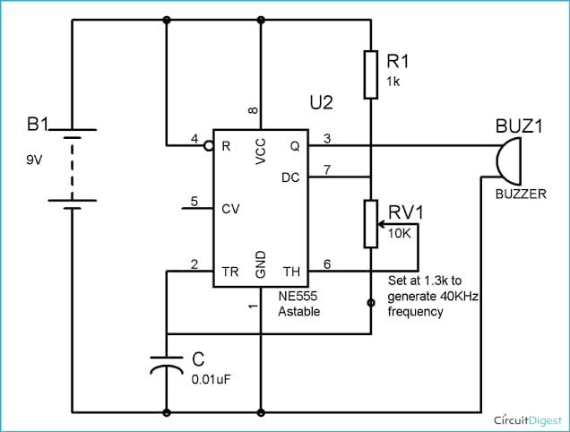

**DESIGN IN PROTEUS:**

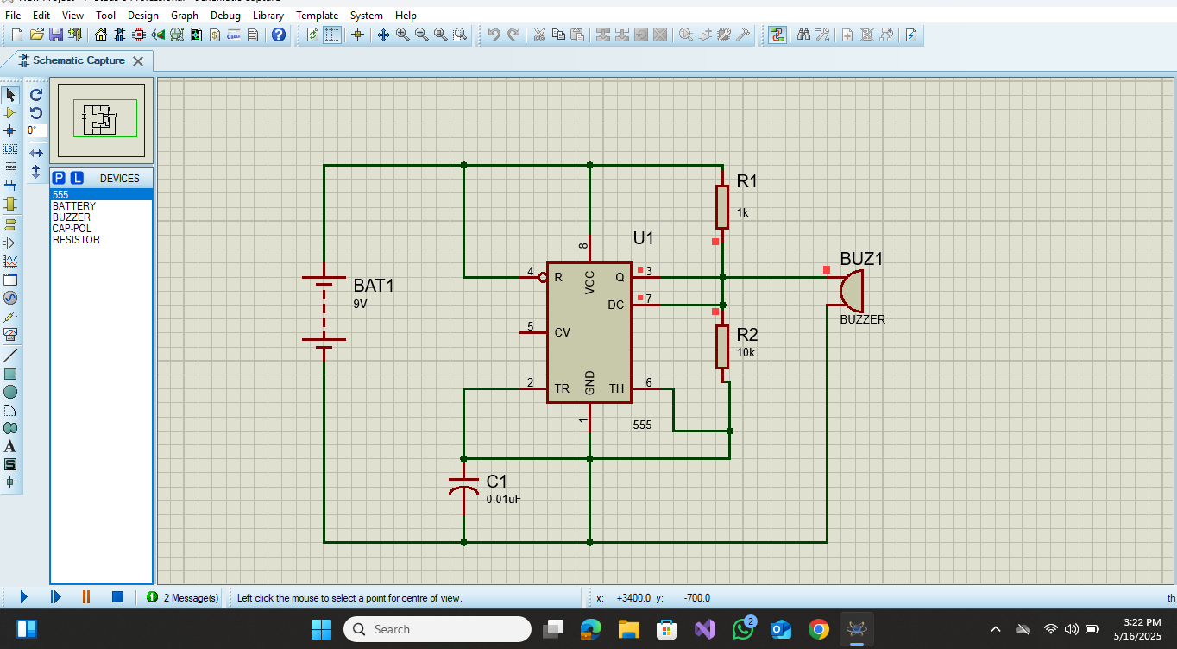

**PROCEDURE:**

1. **Collected all components**  
   We gathered the materials needed for the project, including a breadboard, jumper wires, a 9V battery, resistors, a capacitor, a timer IC (NE555), and a small buzzer that can produce high-frequency sound.
2. **Assembled the circuit on a breadboard**  
   We placed all the components on a breadboard. This helped us connect the parts without soldering, making it easy to test and fix any mistakes.
3. **Connected the timer circuit**  
   We used a NE555 timer IC to create a continuous square wave signal. This signal is used to drive the buzzer and make it vibrate at a very high frequency.
4. **Attached the buzzer**  
   The output of the timer IC was connected to a piezoelectric buzzer. The buzzer produces a high-frequency sound when powered by this signal.
5. **Powered the circuit using a 9V battery**  
   We connected a 9V battery to the circuit using a battery clip. This supplied the required power to run the timer and buzzer.
6. **Tested the buzzer**  
   We switched on the circuit and confirmed that the buzzer was producing a high-pitched sound. The sound is mostly beyond human hearing range but is meant to disturb mosquitoes.
7. **Enclosed the setup in a project box**  
   After testing, we placed the entire circuit in a handmade box to make it look clean and presentable using paper and thermopile. We left an opening for the buzzer so the sound could come out clearly.
8. **Tested in a mosquito-filled area**  
   Finally, we tested the device in a room with mosquitoes. We observed their behavior over 20–30 minutes to see if the sound had any repelling effect.

**HOW IT WORKS:**

1. A timer circuit (NE555 IC) is used to generate a continuous **high-frequency** electrical signal.
2. This signal is sent to a piezoelectric buzzer, which converts it into **sound waves.**
3. The buzzer emits a high-pitched sound that is audible to humans but **uncomfortable for mosquitoes**.
4. Some studies suggest that certain frequencies can irritate or confuse mosquitoes, especially female ones, which are the ones that bite.
5. The idea is that mosquitoes will avoid areas where this sound is present, while the sound remains safe for humans (though it might be a little annoying).
6. The device runs on a 9V battery, making it portable and easy to use indoors for short periods of time.

**FINAL PROJECT:**

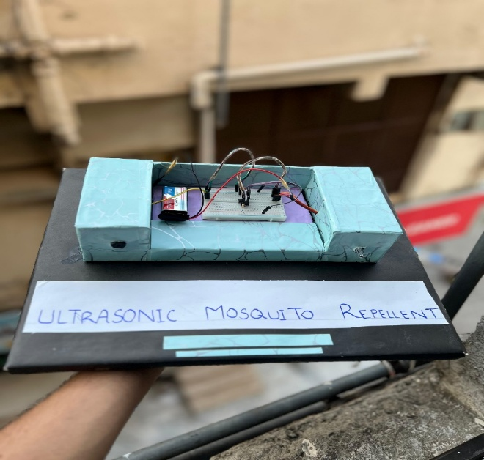

**REFERENCES:**

Video is also available on Github. You can check out by using this link

<https://github.com/zainabbas591/ultrasonic-mosquito-repellent/tree/main>

**CONCLUSION:**

We successfully built a simple mosquito repellent that uses high-frequency sound to help keep mosquitoes away. The buzzer produced a sound that was audible to humans but still showed some effect in repelling mosquitoes. This project helped us apply basic physics and electronics to solve a real-life problem in an eco-friendly way.